**EXPERIMENT: 3**

**1.TITLE:**

AWT and SWING

**2.OBJECTIVE:**

2.1. To be familiar with UI Component and Container of Java AWT.

2.2. To be familiar with UI Component and Container of Java Swing.

2.3. To perform event handling using swing.

**3.THEORY:**

AWT is a user interface toolkit provided by Java programming language class library.

Components is a graphical element that builds graphical user interface.

Containers contain and control the layout of components.

Swing is a framework that provides more powerful and flexible components than does the AWT.

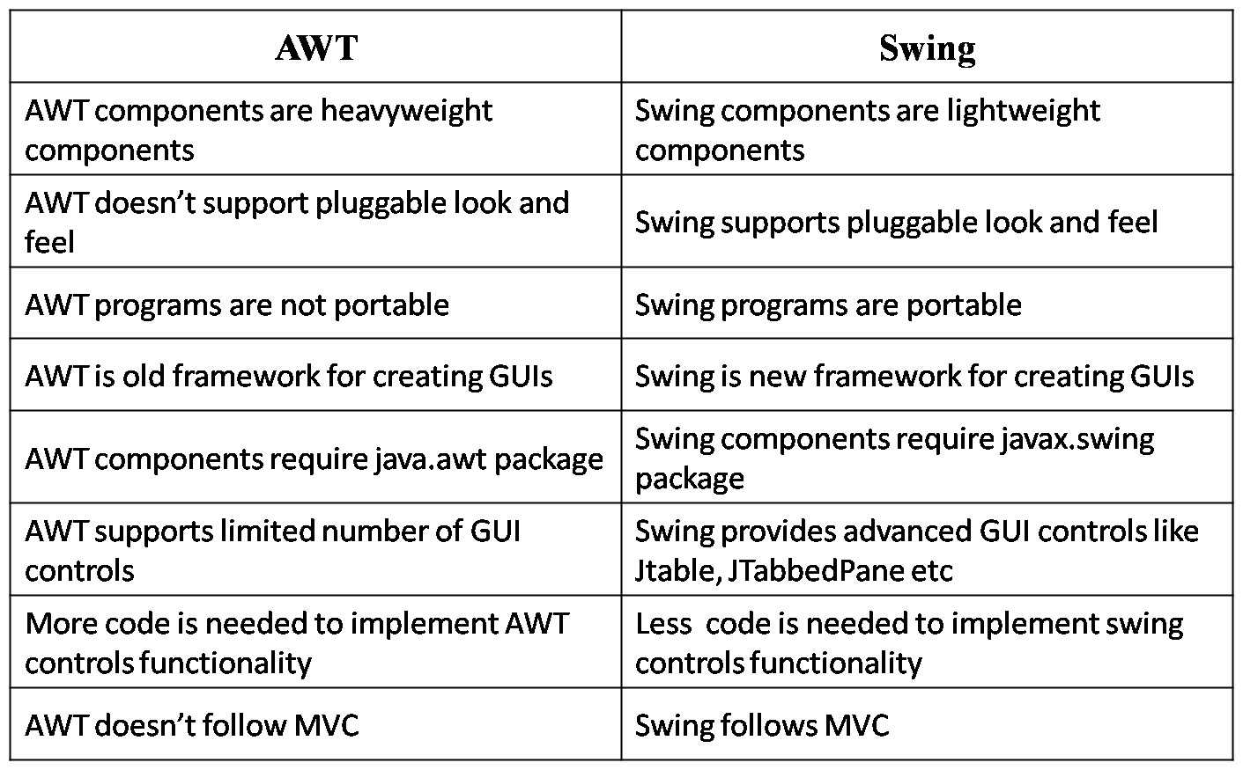

**4.IMPLEMENTATION:**

PROGRAM 4.1. To be familiar with UI Component and Container of Java AWT.

import java.awt.*;

class awt

{

Frame f;

Label l1,l2,l3,l4,l5,l6,l7,l8,l9;

Image icon;

Button b1,b2;

Checkbox c1,c2,c3,c4;

Choice ch1;

List list;

Scrollbar s;

TextField t1,t2,t3,t4;

TextArea text;

Font f1,f2;

awt()

{

f=new Frame("Registration Form");

f.setSize(800,700);

f1=new Font("Times New Roman",Font.BOLD,28);

f2=new Font("Times New Roman",Font.PLAIN,22);

s=new Scrollbar();

s.setBounds(670,0,30,1000);

f.add(s);

l1=new Label("Registration Form");

l1.setBounds(200, 50, 800, 50);

l1.setFont(f1);

f.add(l1);

l2=new Label("Name:");

l2.setBounds(100, 100, 150, 30);

l2.setFont(f2);

f.add(l2);

t2=new TextField(" ");

t2.setBounds(250,100,300,30);

t2.setFont(f2);

f.add(t2);

l3=new Label("Father's Name:");

l3.setBounds(100, 150, 150, 30);

l3.setFont(f2);

f.add(l3);

t3=new TextField(" ");

t3.setBounds(250,150,300,30);

t3.setFont(f2);

f.add(t3);

l4=new Label("Age:");

l4.setBounds(100, 200, 150, 30);

l4.setFont(f2);

f.add(l4);

t4=new TextField(" ");

t4.setBounds(250,200,300,30);

t4.setFont(f2);

f.add(t4);

l5=new Label("Course:");

l5.setBounds(100, 250, 150, 30);

l5.setFont(f2);

f.add(l5);

ch1=new Choice();

ch1.setBounds(250,250,300,30);

ch1.add("C");

ch1.add("C++");

ch1.add("Java");

ch1.add("Python");

ch1.add("C#");

f.add(ch1);

l6=new Label("Hobbies:");

l6.setBounds(100, 300, 150, 30);

l6.setFont(f2);

f.add(l6);

c1=new Checkbox("Drawing");

c1.setBounds(250, 300, 75, 30);

f.add(c1);

c2=new Checkbox("Singing");

c2.setBounds(325, 300, 75, 30);

f.add(c2);

c3=new Checkbox("Music");

c3.setBounds(400, 300, 75, 30);

f.add(c3);

c4=new Checkbox("Others");

c4.setBounds(475, 300, 75, 30);

f.add(c4);

l7=new Label("Address:");

l7.setBounds(100, 350, 150, 30);

l7.setFont(f2);

f.add(l7);

text=new TextArea(10,30);

text.setBounds(250, 350, 300, 100);

f.add(text);

l8=new Label("Favourite Singer:");

l8.setBounds(100, 500, 150, 30);

l8.setFont(f2);

f.add(l8);

list=new List(5);

list.setBounds(250,500,300,60);

list.add("Arijit Singh");

list.add("Atif Aslam");

f.add(list);

b1=new Button("Submit");

b1.setBounds(100, 570, 150, 30);

f.add(b1);

f.setLayout(null);

f.setVisible(true);

}

public static void main(String[] args) {

new awt();

}

}

OUTPUT:

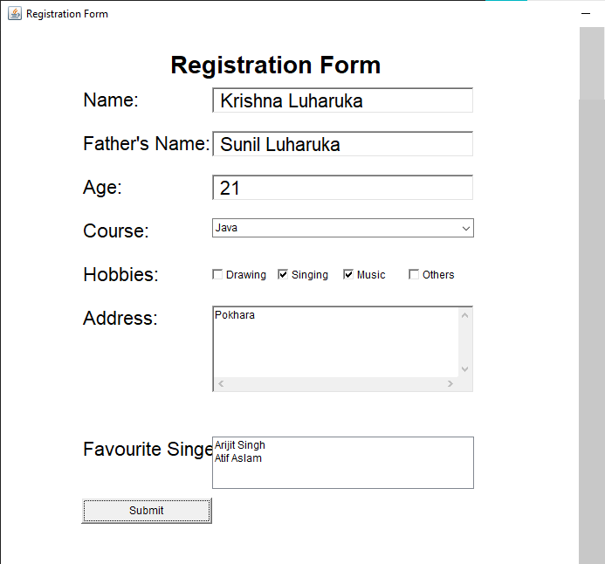

PROGRAM 4.2. To be familiar with UI Component and Container of Java Swing.

*import javax.swing.*;*

*public class swing {*

*JFrame j;*

*JLabel l1,l2,l3,l4,l5,l6,l7,l8,l9;*

*ImageIcon i;*

*JTextField t1,t2;*

*JButton b;*

*JToggleButton tb;*

*JCheckBox c;*

*ButtonGroup bg;*

*JRadioButton r,sa;*

*JTabbedPane tp;*

*JList l;*

*JComboBox cb;*

*JTable tbl;*

*JScrollPane s;*

*swing()*

*{*

*j=new JFrame("Swing");*

*j.setSize(500,500);*

*tp=new JTabbedPane();*

*tp.setBounds(25,25,450,400);*

*j.add(tp);*

*i=new ImageIcon("C:\\Users\\Dell\\Desktop\\java 2\\kpk\\jmc.jpg");*

*j.add(new JLabel(i));*

*l1=new JLabel("Registration Form");*

*l1.setBounds(50,50,200,20);*

*j.add(l1);*

*l2=new JLabel("Name");*

*l2.setBounds(50,70,100,20);*

*j.add(l2);*

*t1=new JTextField();*

*t1.setBounds(150,70,200,20);*

*j.add(t1);*

*l3=new JLabel("Father's Name");*

*l3.setBounds(50,90,100,20);*

*j.add(l3);*

*t2=new JTextField();*

*t2.setBounds(150,90,200,20);*

*j.add(t2);*

*l4=new JLabel("Nationality");*

*l4.setBounds(50,110,100,20);*

*j.add(l4);*

*String a[]={"Nepali","Indian","Chinese","Japanese"};*

*cb=new JComboBox(a);*

*cb.setBounds(150,110,200,20);*

*j.add(cb);*

*l5=new JLabel("Gender");*

*l5.setBounds(50,130,100,20);*

*j.add(l5);*

*bg=new ButtonGroup();*

*r=new JRadioButton("Male");*

*r.setBounds(150,130,100,20);*

*j.add(r);*

*sa=new JRadioButton("Female");*

*sa.setBounds(250,130,100,20);*

*j.add(sa);*

*bg.add(r);*

*bg.add(sa);*

*String data[][]={{"S.L.C.","","","",""},{"10+2","","","",""}};*

*String column[]={"Examination","Board or University","Passed year",*

*"RollNo","Division"};*

*tbl=new JTable(data,column);*

*s=new JScrollPane(tbl);*

*s.setBounds(50,160,400,50);*

*j.add(s);*

*l6=new JLabel("Subjects List");*

*l6.setBounds(50,220,100,20);*

*j.add(l6);*

*String sub[]={"Marketing","Economics","Advanced Java"};*

*l=new JList(sub);*

*l.setBounds(150,220,150,60);*

*j.add(l);*

*c=new JCheckBox("I agree to all the terms and conditions");*

*c.setBounds(50,290,400,20);*

*j.add(c);*

*tb=new JToggleButton("On");*

*tb.setBounds(50,310,100,20);*

*j.add(tb);*

*b=new JButton("Submit");*

*b.setBounds(160,310,100,20);*

*j.add(b);*

*j.setLayout(null);*

*j.setVisible(true);*

*}*

*public static void main(String[] args) {*

*new swing();*

*}*

*}*

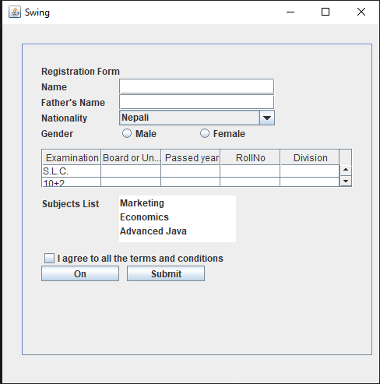

**PROGRAM 4.3**. To perform event handling using swing.

*import javax.swing.*;*

*import java.awt.*;*

*import java.awt.event.*;*

*class keylistener implements KeyListener*

*{*

*JFrame j;*

*JTextArea a;*

*keylistener(){*

*j=new JFrame("Key Listener");*

*j.setSize(600,600);*

*a=new JTextArea();*

*a.setSize(200,200);*

*j.add(a);*

*a.addKeyListener(this);*

*j.setLayout(null);*

*j.setVisible(true);*

*}*

*public void keyPressed(KeyEvent e)*

*{*

*System.out.println("Key pressed");*

*}*

*public void keyTyped(KeyEvent e)*

*{*

*System.out.println("key typed");*

*}*

*public void keyReleased(KeyEvent e)*

*{*

*System.out.println("Key released");*

*}*

*public static void main(String args[])*

*{*

*new keylistener();*

*}*

*}*

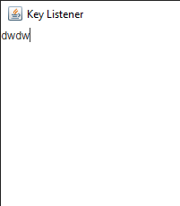

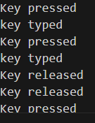

**5.OUTPUT AND DISCUSSION:**

* The various components and containers of AWT are used in program 4.1.
* The various components and containers of Swing are used in program 4.2.
* The event handling is done using swing in program 4.3.

**6. CONCLUSION:**

The awt and swing component and container were used and been familiar in lab successfully.